Perfect Rhyme Couplets

🎯 What is Perfect Rhyme Couplets
# Source: AI Source: Provided by: [Data Path: Persons Table -> ID Column: 1, Name_En Column: Motasem Essam] -> From: [Chatgpt (GPT-4-turbo)] on [8/2/2025]
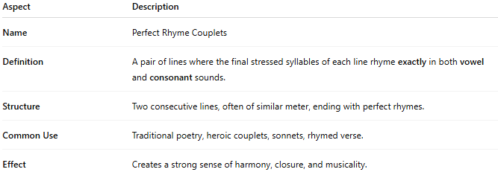
Aspect | Description
Name | Perfect Rhyme Couplets
Definition | A pair of lines where the final stressed syllables of each line rhyme exactly in both vowel and consonant sounds.
Structure | Two consecutive lines, often of similar meter, ending with perfect rhymes.
Common Use | Traditional poetry, heroic couplets, sonnets, rhymed verse.
Effect | Creates a strong sense of harmony, closure, and musicality.

✅ Example of Perfect Rhyme in a Couplet
# Source: AI Source: Provided by: [Data Path: Persons Table -> ID Column: 1, Name_En Column: Motasem Essam] -> From: [Chatgpt (GPT-4-turbo)] on [8/2/2025]

The sky grew dark, the winds took flight
The trees bent low beneath the night
- "flight" / "night" is a perfect rhyme: identical vowel (long "i") and final consonant ("t").

